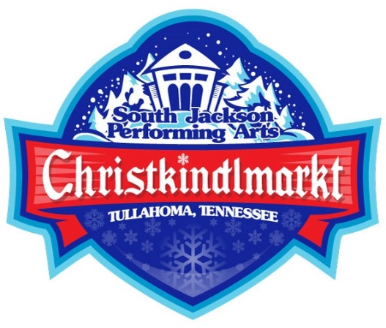

Welcome to the 5th Annual Christkindlmarkt
presented by South Jackson Civic Association, a Non-Profit Organization,
at Jackson Square Park, 404 South Jackson Street, Tullahoma, TN
Saturday, December 6th, 2025 - Noon until 8:00 p.m.

FOOD VENDOR APPLICATION
ALL BOOTHS $75. Quiet generators allowed.
Food and drink items should include “Holiday inspired” items,
but will not include the sale of beer, wine or alcohol.

Fee due with application. Make checks payable to South Jackson Civic Association (SJCA). Bring by the office or mail to:
PO Box 326, Tullahoma, TN 37388.
If you prefer to pay by credit card, please come by the South Jackson office which is located on the south side of the building, or scan the application and email to office@southjackson.org, then call 931-455-5321 to make payment.

The Christkindlmarkt is a rain or shine event, no refunds will be made.

Contact Name ___________________________ Signature _________________________

Organization _________________________________________________________________

Address _____________________________________________________________________

Contact number ___________________ Email address ____________________________

Description of items for sale __________________________________________________

______________________________________________________________________________

Food and beverage vendors are responsible for their own insurance, licenses, and permits. They must list the Tullahoma South Jackson Civic Association, Inc. as an additionally insured entity on their certificates of insurance and submit a copy with this form.

Booth setup may begin at 8:00 a.m. and will need to be ready no later than 11:00 a.m. We request that booths not be taken down until 8:00 p.m.

PLEASE NOTE:

Your booth location will be determined by the festival committee.
Booths cannot be re-rented or sold by the vendor.

Vendors will provide tables, chairs, outdoor rated extension cords, and a trash can for your booth.

We recommend use of canopies, table coverings, festive decorations, and costumes if you like.

Jackson Square Park is part of the City of Tullahoma Parks and Recreation Department; therefore, smoking is not permitted.

Any vendor with an open flame or hot grease is required to have a 20-pound fire extinguisher on hand.

Vendors agree to take full responsibility for the protection of their property.

Food, grease, or ashes may not be dumped on Jackson Square Park property, school board property, or adjoining streets.

Fireworks, smoke bombs, silly string, snappers, items with foul language or sexual content are not permitted in booths.

No solicitation of any kind is allowed. Brochures for non-profit organizations may be available in their booth.

Please promote your participation in these events by joining the event on our Facebook page and liking and sharing the posts made.

